**Ideation Phase**

**Brainstorm & Idea Prioritization Template**

|  |  |
| --- | --- |
| Date | 26 June 2025 |
| Team ID | LTVIP2025TMID39268 |
| Project Name | Hematovision – Advanced Blood Cell Classification using Transfer Learning |
| Maximum Marks | 4 Marks |

**Brainstorm & Idea Prioritization Template:**

Brainstorming provides a free and open environment that encourages everyone within a team to participate in the creative thinking process that leads to problem solving. Prioritizing volume over value, out-of-the-box ideas are welcome and built upon, and all participants are encouraged to collaborate, helping each other develop a rich amount of creative solutions.

Use this template in your own brainstorming sessions so your team can unleash their imagination and start shaping concepts even if you're not sitting in the same room.

Reference: https://www.mural.co/templates/brainstorm-and-idea-prioritization

**Step-1: Team Gathering, Collaboration and Select the Problem Statement**

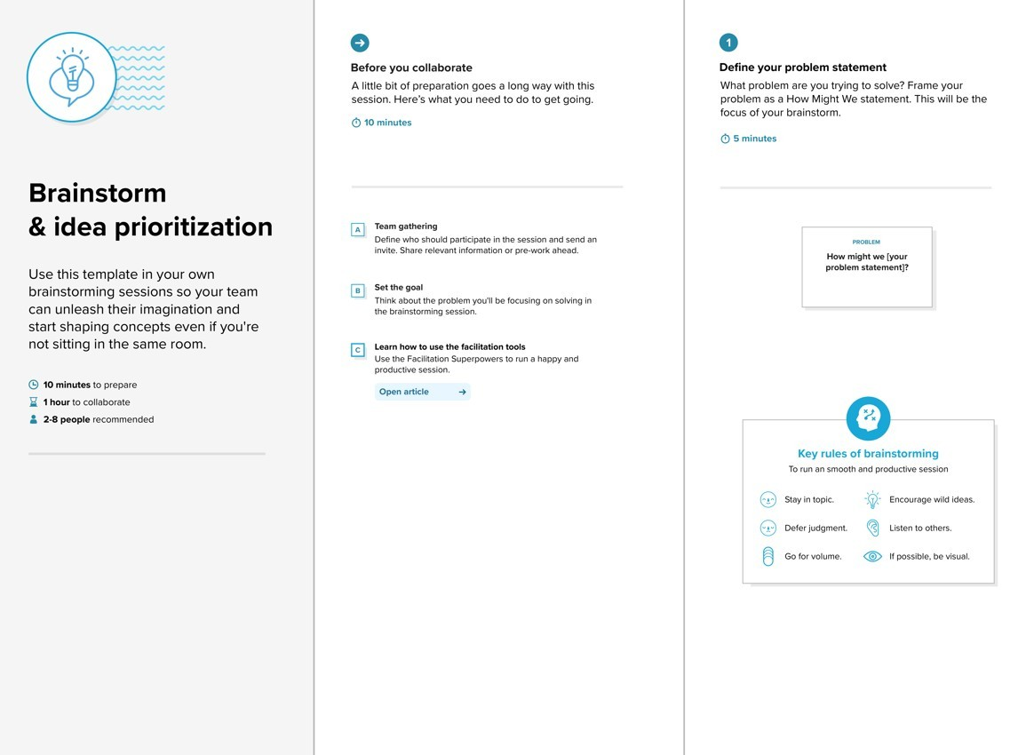

**Step-2: Brainstorm, Idea Listing and Grouping**



|  |  |  |  |
| --- | --- | --- | --- |
| **Person1:**  Try  MobileNetv2/  DenseNet for Performance comparision  **Person3**:  Show Blood cell type prediction with confidence score | **Person2**:  Flask-based web interface for uploading blood smear images  **Person4**:  Deploy on Render, Railway, or Hugging Face  Spaces | **1. Model**  **Development & Data**  **Handling**  Use MobileNetV2 pretrained on ImageNet for feature extraction  Compare performance with EfficientNet or  DenseNet  Augment dataset: flip, zoom, rotation, shift Balance dataset using oversampling or | **2. UI &**  **Interaction (Web**  **App)**  Flask web app for uploading microscopic images  Drag-and-drop or file browser input Display prediction with cell type + confidence score Use color-coded labels or bounding |

boxes

**3. Deployment & Output Sharing**

Host the app using Render / Railway /

Hugging Face Spaces

Generate downloadable report (PDF) with prediction result

Store recent history and allow image reevaluation

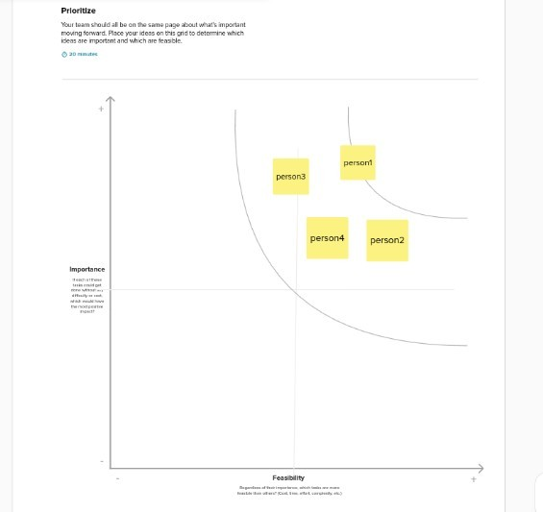

**Step3:Idea prioritization**